Ordination and Installation Service November 26, 2023

Prelude

Call to Worship Psalm 92:1-4

Prayer of Invocation RE Josh Stenger

Nature and Importance of Ordination TE John Ceselsky

Responsive Scripture Reading TE Mark Tippin

Psalm 16 Hymnal, p. 788

Keep me safe, O God

for in you I take refuge.

I said to the LORD, “You are my Lord; apart from you I have no good thing.”

As for the saints who are in the land, they are the glorious ones in whom is all my delight.

The sorrows of those will increase who run after other gods.

I will not pour out their libations of blood or take up their names on my lips.

LORD, you have assigned me my portion and my cup; you have made my lot secure.

The boundary lines have fallen for me in pleasant places; surely I have a delightful inheritance.

I will praise the LORD, who counsels me; even at night my heart instructs me.

I have set the LORD always before me. Because he is at my right hand, I will not be shaken.

Therefore my heart is glad and my tongue rejoices; my body also will rest secure,

because you will not abandon me to the grave, nor will you let your Holy One see decay.

You have made known to me the path of life;

you will fill me with joy in your presence, with eternal pleasures at your right hand.

*Hymn #469 “How Sweet and Awesome Is the Place”

Sermon Rev. Greg Dutcher

Questions for Ordination TE Tom Frech

Questions to the Congregation RE Steve Maddox

Prayer and Laying on of Hands

Charge to the Pastor TE Allen Smith

Charge to the Congregation TE David Milligan

*Hymn #347 “The Church’s One Foundation”

*Benediction TE Bryant Park

Postlude

* Please stand if you are able.

Special Thanks

TE John Ceselsky, Aisquith Presbyterian Church

Rev. Greg Dutcher, Christ Fellowship Church

RE Tom Feazell, Loch Raven Presbyterian Church

TE Tom Frech, Gateway Community of Faith

RE Steve Maddox, Loch Raven Presbyterian Church

TE David Milligan, Loch Raven Presbyterian Church

RE John Selby, Loch Raven Presbyterian Church

TE Allen Smith, Bay Area Community Church

RE Josh Stenger, Loch Raven Presbyterian Church

TE Mark Tippin, Valley Presbyterian Church

Pianist Anne Yumoto

Gina Lammers & all who helped to prepare the meal.

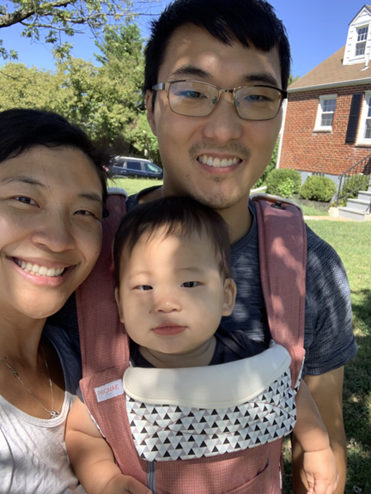

Prior to ordination, Bryant served as a Pastoral Assistant at Loch Raven Presbyterian Church. He and his wife Joyce have been married for over nine years and they have one son, Isaac, who was born on Thanksgiving 2022. Bryant graduated from Reformed Theological Seminary in 2019. He grew up in Baltimore County and came to know the Lord after college.

