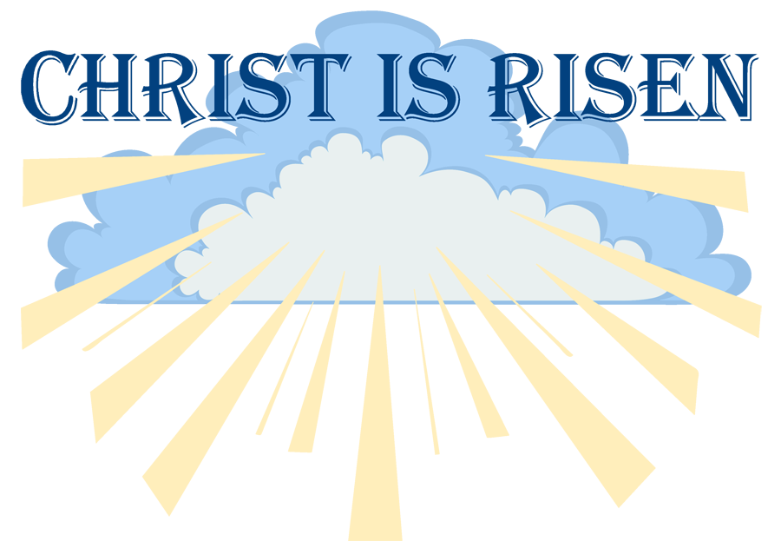

Easter Sunday Sunrise Service
April 9, 2023
7:30 am

Call to Worship 1 Cor. 15:1-11
*Praise Songs It Was Finished Upon That Cross/Resurrection Hymn

*The Confession of Faith (from the Westminster Larger Catechism, Questions 52 & 87)
Q.52. How was Christ exalted in his resurrection?
A. Christ was exalted in His resurrection, in that, not having seen corruption in death (in which it was not possible for Him to be held), and having the very same body in which he suffered, with its essential properties (but without mortality, and other common infirmities belonging to this life), really united to His soul, He rose again from the dead the third day by His own power; whereby He declared Himself to be the Son of God, to have satisfied divine justice, to have vanquished death and him that had the power of it, and to be Lord of the living and the dead. All this He did as a representative person, the head of His church, for their justification, making them alive in grace, supporting them against enemies, and assuring them of their resurrection from the dead at the last day

Q.87. What are we to believe concerning the resurrection?
A. We are to believe, that at the last day, there shall be a general resurrection of the dead, both of the just and unjust; when they that are then found alive shall in a moment be changed; and the actual bodies of the dead that are laid in the grave, being then again united to their souls forever, shall be raised up by the power of Christ. The bodies of the just, by the Spirit of Christ, and by virtue of his resurrection as their Head, shall be raised in power, spiritual and incorruptible, and made like His glorious body: and the bodies of the wicked shall be raised up in dishonor by Him, as an offended judge.

Prayer
Hymn #276 “Up from the Grave He Arose”
Scripture Matt 28:1-10
Sermon “With Fear and Great Joy”
Mr. Bryant Park

Hymn #274 “Thine Be the Glory”
Benediction

